Topic: Investment Decision Journal
- An app that compiles/aggregates news articles, data and analyst ratings for stocks. Stocks specifically on the NSX and the ASX
- Users can add their current holdings, and enter and update their thesis for stocks.
- They can add their bear and bull case
- They can add their confidence level
- They can add their predictions for future price levels and business data

- Users set a date for review on their thesis that triggers a notification to help them stay consistent in their views. They can write a reflection / update holdings when the alert triggers, which turns can help them learn how to analyse better In the future
- Review feature could also function as getting users to review their watchlist holdings, to see if the right time to buy for them has come yet
- Clean portfolio dashboard with sector exposure by percentage
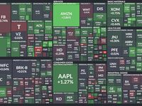
Homepage that looks something like this
Review Urgency Heatmap
Tile size = portfolio weighting
Color = days until next review
- Green = recently reviewed
- Yellow = review due soon
- Red = overdue review

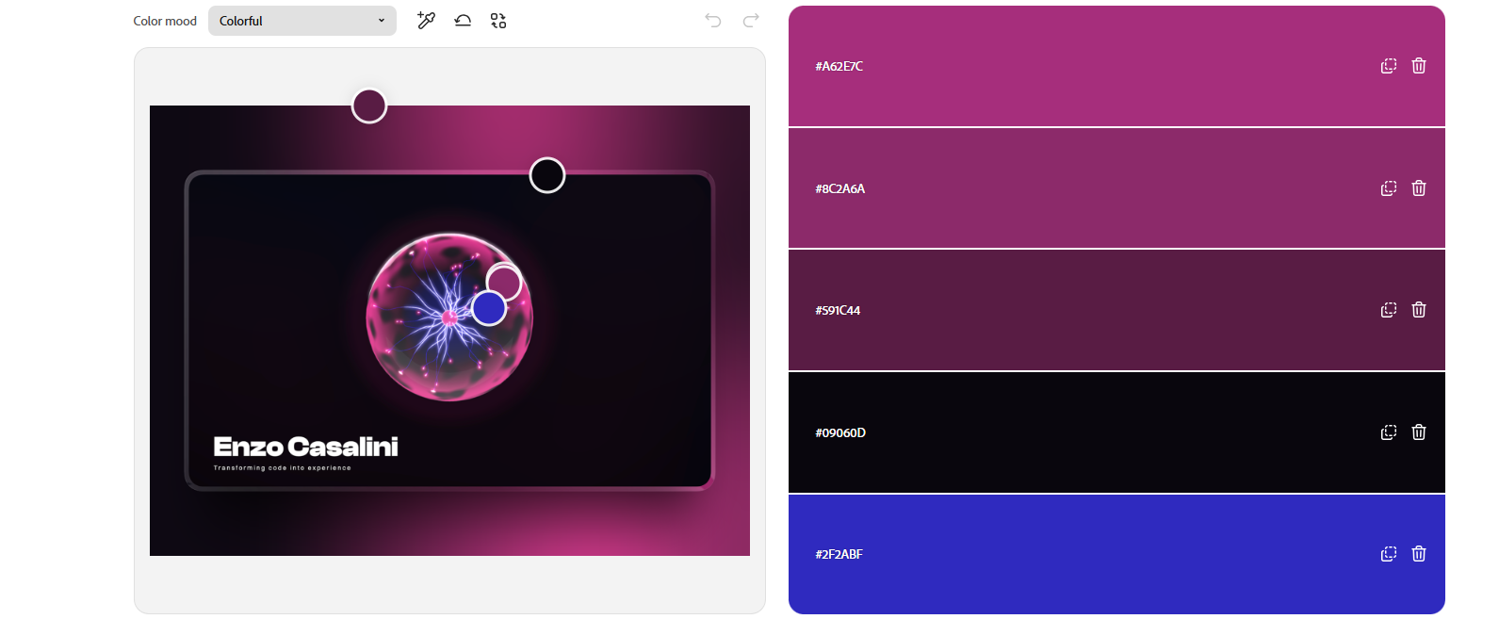
Color Palette Generator From Image | Adobe Express​
Enzo Casalini - Creative Developer Portfolio

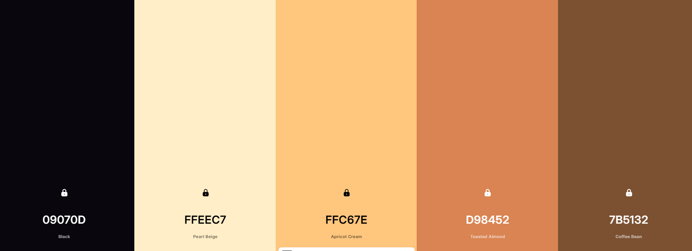

Ai animated javascript blackhole inspired by the tradingview 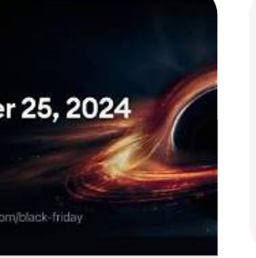
Create a Palette - Coolors 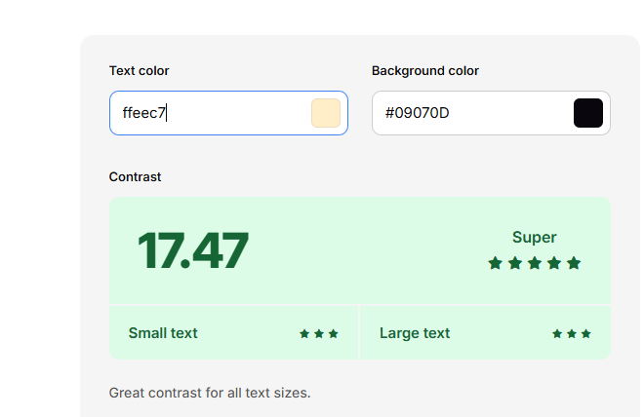

My version:
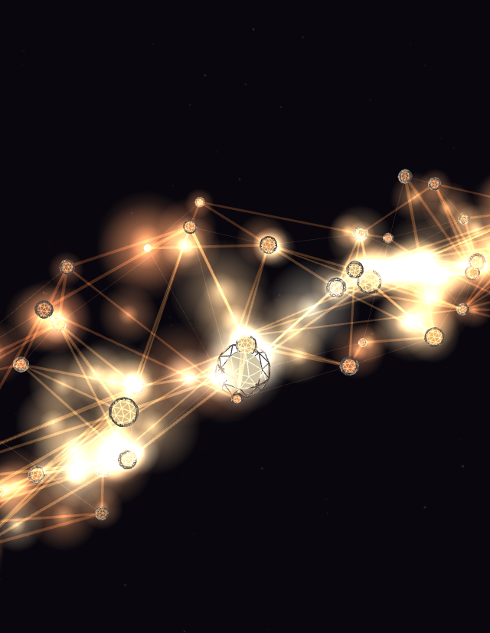
Prompts used to build this animation
These are the prompts (in order) from the conversation that produced the decision-network animation in this folder. Reusing this sequence with Claude (or adapting it for another AI) should reproduce something close to this result.

1.
what is the best AI to create a javascript animation for the home page of my website [pasted a project brief for an Investment Decision Journal app — a stock research/portfolio tracking tool with thesis tracking, bull/bear cases, confidence levels, review reminders, and a portfolio dashboard], also mentioned wanting something like an animated blackhole/plasma-ball effect inspired by TradingView, and asked what objects could work and which AI is best for it.
2.
like a blackhole or something
3. (uploaded a 5-color palette image: Black #09070D, Pearl Beige #FFEEC7, Apricot Cream #FFC67E, Toasted Almond #D98452, Coffee Bean #7B5132)
this is my colour palete, build me a high detailed design i can run in vs code
(This produced the first animation — a black hole/accretion disk hero. Several other variants were built across the conversation: candlestick wave field, fractal cube field, uranium decay, magnetic dipole field, psychedelic mandala, anatomical figure. The prompts below are specifically the ones for the decision network.)
4.
can we try the neural decision tree network
(This was selected from a list of suggested concepts offered earlier in conversation: "Neural/decision tree network — branching nodes and connections that pulse with light traveling along edges, like signals firing through a decision-making process." Claude built the first version: 4 layers — raw data, signals, thesis, decision core — with nodes, glow sprites, simple edges, and traveling pulses.)
5.
can i get just the code for the animation, none of the website part and can you write me the prompts out that i used to get you to make the animation
(This request — produced the files in this folder: main.js stripped of all page-specific HTML/CSS/DOM coupling, a minimal usage-only index.html, and this prompt log.)

Earlier prompt, for context (the rebuild that preceded this)
Before the "just the code" request above, there was a separate rebuild request that significantly increased the network's detail and realism. If you want to reproduce that specific version of the network (the one actually present in this folder — dense connections, lateral edges, cascading signal propagation, structured nodes, HUD), the prompt was:
can you re do the decision tree network to make it more realistic and interesting because i think its really cool but not detailed enough
In response, Claude (without being given specifics) chose to add:
- Dense many-to-many connections (2-4 per node into the next layer, instead of 1-2)
- Lateral peer connections within each layer
- Instanced-cylinder edges with real thickness instead of flat lines
- A coherent cascading signal-propagation system (a "thought" originates at a random data node and visibly ripples layer-by-layer to the core, rather than independent unrelated pulses)
- Structured nodes (core sphere + rotating wireframe shell + orbital ring)
- A live HUD readout (node/edge/cascade counts, a "confidence" percentage derived from core activation)
- A performance pass converting ~86 separate per-node draw calls into 2 instanced meshes
Font testing:
Specification:
I want a font that looks clean, and minimalistic. Investment decisions should be about precision so a clear font will help make the user experience feel precise and calibrated.
Selection Embed Code - Google Fonts
Urbanist:
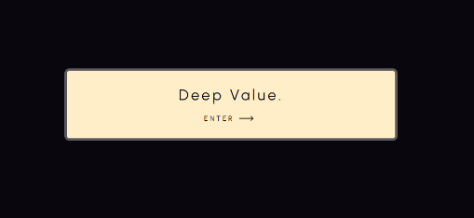

Sensation:
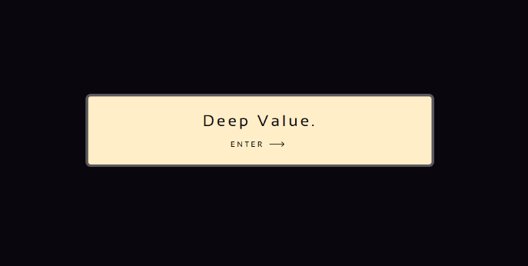
I chose to go with urbanist because I feel like the letter design feels more modern, sensation looks closer to a type writer. I also think that it looks a bit more rigid, the sensation letters are very square and that’s not what I want for a welcoming page. More rounded fonts make the user experience more inviting.
A criteria stuff:
Two relevant implications:
- Accessibility. Because my app is designed for all investors its important that people with disabilities can use it. I will design the project with high contrast between text and background, Titles for images for e readers – for the blind, the ability to magnify text, etc.
- Privacy. Because making an investment decision journal requires inputting personal monetary decisions which could be considered quite private data its important that users privacy is kept. I will do this by asking for permission for cookies and showing a disclaimer about data I will need to collect, and how it will not be shared.

Early stage Feedback
Name: Nikhil
Thoughts: I think that it has a nice colour scheme. And there are some nice aminations that you have added from the nicegui. I think the next stop is adding a enter button or making it so you can enter your name by clicking the enter button on your keyboard. I also feel that you could make the writing a little bit bigger because there is so much space that isn’t really doing anything

Two methods of project management for planning:
- https://www.figma.com/make/DsBcsbG96y2TW2J4hgVnID/Stock-research-app?t=hVCeLNTpkXmkmuug-1
- Comp Sci | Trello
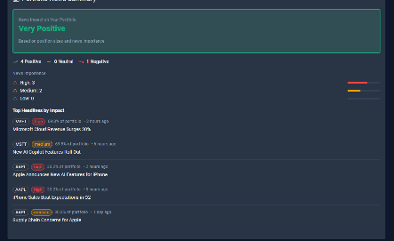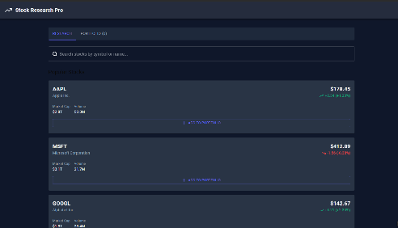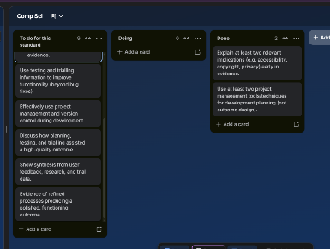
Required component breakdown:
- Interesting animation for the background
- Ability to input stock holdings by value and share size
- A wide variety of stocks to choose from
- Ability to input users own thesis, and record it
- Ability to send users notifications and set review dates for their thesis

